DES Video and Audio Encryption and Decryption
Advanced Cryptography I | MSIS Semester 1
Mian Salman Hassan and Muhammad Asif | Submitted to Prof. Sadiqa Arshad | 19 October 2026

1. Objective
A video file contains two separate streams: the picture and the sound. Encrypting only the picture still leaves the audio fully audible. The goal of this assignment was to encrypt both streams of the same clip using DES, decrypt them back correctly, and compare three modes of operation.

2. What was built
- DES implemented from scratch (no cryptographic library), verified against the official test vector.
- Three modes of operation: ECB, CTR and CFB.
- Decryption for all three modes, with the recovered data checked byte for byte.
- A pipeline that encrypts the video frames and the audio track of the same clip.
- A playable encrypted video, which shows static on screen and static through the speakers.
- Security analysis: entropy, histograms, pixel correlation, key sensitivity and performance.
- A browser interface for running the pipeline on any video, covered in section 13.

3. How it works
DES core
DES splits data into 8 byte blocks and runs each block through 16 rounds. The implementation was checked against the standard test vector: key 133457799BBCDFF1 with plaintext 0123456789ABCDEF produces 85E813540F0AB405. This confirms the permutation tables and S-boxes are correct.
Decryption is the same 16 rounds with the round keys applied in reverse order. The round function is never inverted, because the Feistel structure allows the previous half to be recovered from the current halves. This is why early DES hardware used one circuit for both directions.
Note that CTR and CFB never need a decryption function at all. Both encrypt a counter or a register to produce a keystream and then XOR it with the data, so only the forward direction is ever used. ECB was the only mode that required true decryption.
Video
Each frame is read as a grid of pixel values, which is simply a block of bytes. All frames are joined into one long byte string and encrypted in a single pass. This matters: if each frame were encrypted separately in CTR mode, the counter would restart at zero for every frame and every frame would receive the same keystream. Two frames encrypted with the same keystream can be XORed together to remove the keystream entirely, which would leak the picture. Encrypting the frames as one continuous stream prevents this.
Audio
ffmpeg extracts the audio from the MP4 into a WAV file. A WAV is a short header followed by raw numbers describing the sound wave. Those numbers are bytes, so DES treats them exactly like pixels. The encrypted samples are written back into a WAV, which plays as static.

4. Result: comparison of modes
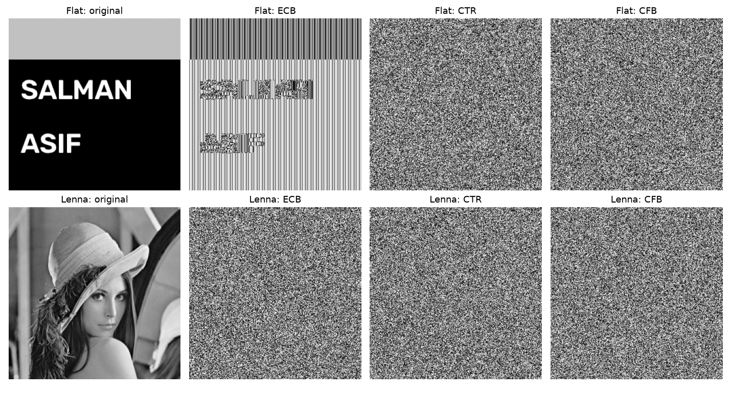
Figure 1. The same two images encrypted with ECB, CTR and CFB. The text survives ECB. Lenna does not reveal anything under ECB, even though ECB is equally broken in both cases.
To measure the leak, duplicate 8 byte blocks were counted before and after encryption.
Data | Plaintext duplicates | ECB | CTR | CFB
Flat image with text | 7,673 of 8,192 | 7,673 | 0 | 0
Lenna photograph | 32 of 8,192 | 32 | 0 | 0
Video, 10 frames | 14,536 of 72,000 | 14,536 | 0 | 0

Table 1. ECB keeps the number of duplicate blocks exactly the same. CTR and CFB remove them completely.
ECB encrypts every block independently with the same key, so two identical input blocks always produce two identical output blocks. The pattern of repeats passes straight through, and that pattern is the leaked picture.
The two rows of Figure 1 are the important part. The flat image has 7,673 repeated blocks out of 8,192, so almost all of its structure survives and the words stay readable. Lenna has only 32 repeats, because a detailed photograph rarely repeats the same 8 pixels, so her ECB result looks like noise. The mode is just as broken in both cases.
Two conclusions follow. First, ECB is especially dangerous for video, because consecutive frames are nearly identical and therefore highly repetitive. Second, an encrypted image that looks like noise is not proof of security. Visual inspection is not a security test.
ECB also produces output 8 bytes longer, because it requires padding. A full extra block is added even when the data already fits exactly, otherwise the receiver cannot tell padding from real data. CTR and CFB add nothing.

5. Result: statistical analysis
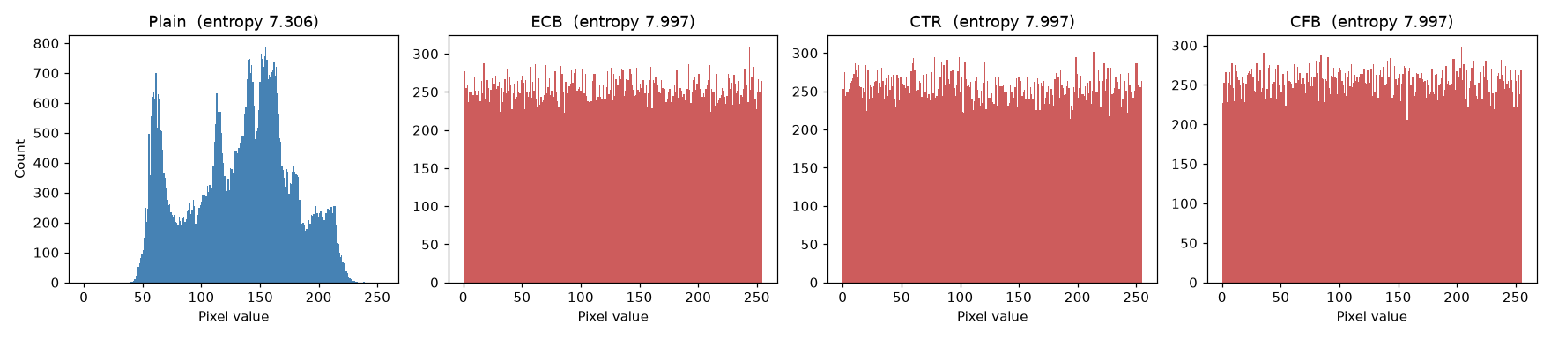
Figure 2. Pixel value distribution. The original has peaks and gaps. All three encrypted versions are flat.
 | Entropy (max 8.0) | Horizontal | Vertical | Diagonal
Original | 7.3059 | 0.9461 | 0.9726 | 0.9237
ECB | 7.9974 | 0.0047 | 0.0013 | 0.0044
CTR | 7.9968 | 0.0010 | 0.0050 | 0.0016
CFB | 7.9975 | -0.0058 | 0.0056 | -0.0002

Table 2. Entropy and correlation between neighbouring pixels.
- Entropy measures information per byte. The maximum is 8.0, meaning all 256 byte values appear about equally often. All three modes reach roughly 7.997.
- Correlation measures how well a pixel predicts the pixel next to it. A normal photograph scores about 0.95 because neighbouring pixels are nearly the same colour. All three modes reduce this to about zero.
CTR and CFB use a fresh random nonce or IV on every run, so their entropy and correlation figures move slightly in the last decimal place each time. ECB has no nonce, so its numbers are identical on every run. The values above come from a single run of 07_security_analysis.py.
One caution: ECB scores just as well as CTR and CFB on every statistic here, yet Figure 1 shows it is broken. These measurements are necessary but not sufficient. A mode can pass every statistical test and still leak the image.

6. Result: key sensitivity
Keys compared | Bit changed | NPCR | UACI
salman12 and ralman12 | parity bit | 0.00% | 0.00%
salman12 and qalman12 | real key bit | 99.57% | 33.31%

Table 3. Effect of changing one bit of the key.
The first row is the important one. Two different 8 byte keys produced identical ciphertext. The bit that was changed is a parity bit, and the PC1 permutation discards the lowest bit of each of the 8 key bytes. Eight of the 64 bits never reach the algorithm.
This is an experimental demonstration that DES has a 56 bit effective key rather than 64. That small key is why the EFF machine Deep Crack broke DES by brute force in 1998 in under three days, and why DES is not used today.
Changing a real key bit instead changes 99.57% of the ciphertext bytes. The ideal values are 99.6% for NPCR and 33.46% for UACI, so DES meets them.

7. Result: effect of changing the plaintext
A single bit of the input image was flipped and the ciphertexts were compared.
Mode | Bytes changed (NPCR) | Behaviour
ECB | 0.011% | Only the one affected block changes
CTR | 0.002% | Exactly one byte changes
CFB | 99.629% | The change spreads through everything after it

Table 4. The same cipher behaves in three completely different ways depending on the mode.
The CTR row has a real security consequence. Because one changed input bit produces exactly one changed output bit, CTR ciphertext is malleable. Someone who knows or guesses part of the plaintext can flip chosen bits of it without knowing the key, simply by flipping the same bits of the ciphertext. This is why practical systems combine CTR with authentication, such as AES-GCM or an HMAC. Encryption on its own gives confidentiality, not integrity.
The same property has a practical upside. A transmission error in CTR damages only one byte, while in CFB it destroys the remainder of the stream.

8. Video and audio results
  Original frame |   Encrypted | Decrypted

Figure 3. The first video frame at each stage. The decrypted frame is identical to the original, byte for byte.
Both streams were verified. The decrypted video bytes and the decrypted audio bytes matched the originals exactly. The encrypted video file plays as colour static with a hiss, which shows that both the picture and the sound were encrypted.

9. Performance
Measurement | Value
Throughput | about 33 KB per second (4,600 DES blocks per second)
Video, 30 frames at 160x120 | 1,728,000 bytes in 51.8 seconds
Audio, 1 second at 48 kHz mono | 96,482 bytes in 2.9 seconds
Larger run, 60 frames, via the interface | 252.2 s to encrypt, 249.4 s to decrypt, 30.1 KB/s
Difference between modes | none measurable

Table 5. Measured speed.
The last row is a separate, larger job run through the interface. It reached 30.1 KB/s against 33 KB/s for the smaller test, so the rate holds roughly steady as the job grows. This means the time a clip will take can be estimated from its size in advance, which is what the interface does before it starts.
- The mode affects security, not speed. Every mode calls the DES block function the same number of times.
- This figure is not the speed of DES. It is the cost of an educational implementation that stores every single bit as a separate list element. A DES implementation in C runs at tens of megabytes per second, roughly a thousand times faster.
- This is why the clip was reduced to 160x120 and 30 frames. One frame at the original 848x478 would take about 33 seconds on its own, and the full 302 frame clip would need around three hours in each direction.

10. Observation on file size
File | Original | Encrypted | Change
Video file | 48,444 bytes | 247,554 bytes | 5.1 times larger
First frame as PNG | 24,919 bytes | 57,887 bytes | 2.3 times larger

Table 6. Encrypted media takes more space than the original.
Compression works by finding patterns and describing them more briefly. Encryption exists to destroy patterns. Encrypted data therefore cannot be compressed, and the compressor's own overhead makes the file larger than the raw bytes. The practical rule is to compress first and encrypt afterwards. A system that encrypts video before compressing it will produce very large files.

11. A note on how the ciphertext is stored
The actual ciphertext is saved as cipher_video.bin and cipher_audio.bin, and decryption reads those files. It does not read the MP4.
The reason is that MP4 uses lossy compression. Saving ciphertext as an MP4 throws some of it away permanently, so decryption from the MP4 would fail. The file encrypted_preview.mp4 is a viewable picture of the ciphertext, while the .bin file is the ciphertext itself.

12. Limitations and conclusion
- DES has a 56 bit effective key, shown experimentally in section 6. It was broken by brute force in 1998 and should not be used for anything real. AES is the modern choice, or 3DES at minimum.
- The 64 bit block is small. Collisions become a concern after about 2^32 blocks, which is only 32 GB, well within the size of a long video.
- ECB must never be used for media.
- CTR must never reuse the same key and nonce pair.
- CTR alone provides no integrity, as section 7 shows. Authentication must be added.
- This implementation is for learning. It is not constant time, so a real deployment would be open to timing side channel attacks.
The assignment goal was met. Both the video and the audio of the same clip were encrypted and correctly recovered, three modes were compared, and the comparison showed clearly why ECB is unsuitable for media and why CTR is the practical choice for video.

13. Browser interface
As an extension, the pipeline was given a simple interface that runs in a web browser, so any video can be tested without editing the code. It is built with Streamlit, and lives in two files: des_pipeline.py holds the encrypt and decrypt flow as one reusable function, and app.py is the interface itself.
The interface lets the user upload any video, choose the mode, the key, the frame count and the frame size. It checks the typed key against the weak and semi-weak key lists and warns before running. It shows the amount of data and an estimated time before starting, then a progress bar while it works. When it finishes it displays the first frame at all three stages, plays all three videos in the page, and states whether the round trip matched byte for byte.
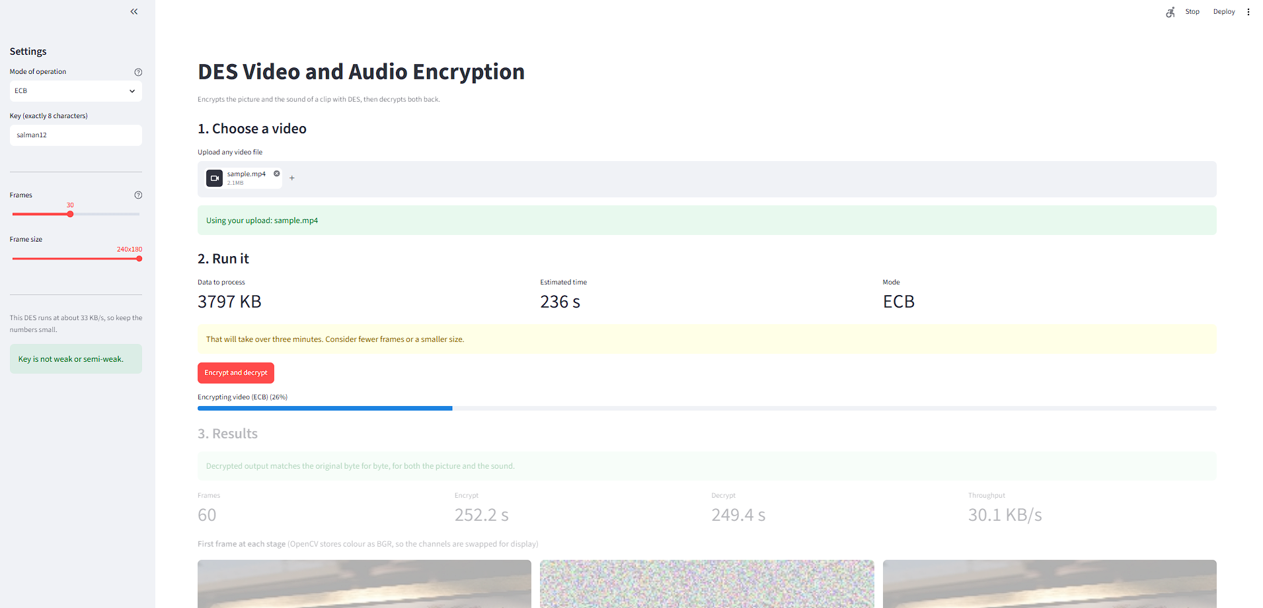
Figure 4. The interface during a run. The settings are on the left, the estimated time is shown before starting, and the progress bar reports the current stage. The results from the previous run are greyed out while the new one is in progress.
The interface is also deployed, so it can be used without installing anything:
https://des-video-encryption-crypto.streamlit.app/
Why des_pipeline.py repeats the mode functions
The versions in des_core.py and des_decrypt.py process all the data in one call and only return once they are finished, so they cannot report how far along they are. Because this DES runs at about 33 KB/s, even a short clip takes close to a minute, and an interface that sits frozen for a minute looks broken. des_pipeline.py therefore runs the same algorithms as explicit loops that report their progress every 500 blocks. The cryptography is identical, only the progress reporting is added.
One practical detail
OpenCV writes video using MPEG-4 Part 2, which web browsers will not play. The pipeline re-encodes its output to H.264 with AAC audio through ffmpeg. Without that step the video players in the page stay blank.

14. How to run the code
Script | What it does
01_text_encryption.py | Text encryption, CTR round trip and single block decryption
02_image_encryption.py | Image encryption and decryption
03_video_frames.py | Video frames round trip
04_audio_encryption.py | Audio extraction, encryption and decryption
05_full_pipeline.py | Full pipeline, produces the playable videos
06_mode_comparison.py | Mode comparison, produces Figure 1
07_security_analysis.py | Statistical analysis, produces Figure 2
des_core.py | The DES algorithm and the three modes
des_decrypt.py | Our decryption functions
des_pipeline.py | Shared pipeline used by the interface
app.py | The browser interface

Table 7. The files in the project.
05_full_pipeline.py works on any video file:
python 05_full_pipeline.py "myvideo.mp4" 20 160 120
The numbers are the frame count, width and height. Larger values take proportionally longer.
To open the browser interface:
python -m streamlit run app.py
The form python -m streamlit is used because pip installs the streamlit launcher into a folder that is not on the system PATH.
Requirements: Python 3 with numpy, opencv-python, matplotlib and imageio-ffmpeg, plus streamlit for the interface. The DES code itself uses only the standard library.

